December 4, 2020

RE: Ex-parte Order Substituting Attorney

<<PROVIDER_SUITNAME>> a/a/o <<INJUREDPARTY_NAME>> v. <<INSURANCECOMPANY_SUITNAME>>, Case No. <<INDEXORAAA_NUMBER>>

Dear Your Honor:

Pursuant to your judicial procedures, please find attached our Ex-parte Order Substituting Attorney for the above-captioned case. Kindly have your judicial assistant docket and serve this order on all parties.

Sincerely,

Sincerely,

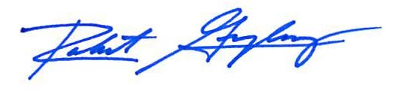

Robert F. Gonzalez, Esq.